ARP Table

ARP Table is used to keep the record of the IP address and MAC address of the devices (source and destination device). For the communication between two devices, it is necessary that the IP address and the MAC address of the source and the destination device should be stored in an ARP table. If there is no record in the table, an ARP broadcast is sent by the source to all the devices in a network. All the devices compare their own IP address with the IP address of the destination device. When the IP address of the device matches with each other, that device sent the response, which is then updated in an ARP table. Each host that is connected to the network should have to maintain an ARP table on its own.

**Example:** Suppose, many devices are connected to a switch. When these devices get connected to the router, the IP addresses of these devices get stored in the cache memory (ARP table). When the device (source) sends an ARP request, the ARP table checks the [IP](https://www.javatpoint.com/ip-full-form) address connected to the device and converts the information into a packet. Then deliver the packet to the appropriate IP address.

Operations in an ARP Table

We can perform many operations in an ARP table such as to display, add and remove ARP entries in the ARP table (ARP cache). To perform these operations, we use an **arp** command offered by the Windows Operating System.

List and Display ARP entries.

You can display the ARP entries by using the command **arp -a**. This list of entries is displayed in the terminal according to the interfaces.

**Steps for displaying the ARP entries**

**Step 1:** Go to the start menu. Open the command **prompt.**

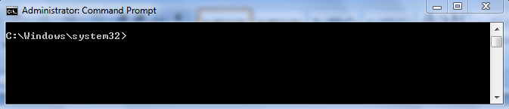

**Step 2:** Type **arp -a** command in the command prompt or terminal and press **enter button**. After pressing the **enter button**, all the ARP entries will display in the command prompt.

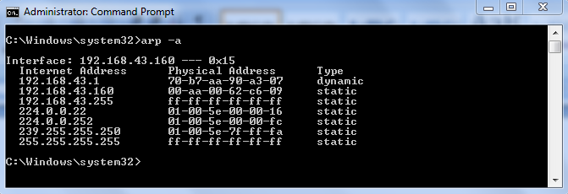

Add static ARP entry.

The ARP table also provides a feature that is adding a static ARP entry to the AP table. With the help of this, we can add the **IP address** and **MAC addres**s to the **ARP table** (ARP cache). These entries will be stored until the computer restarts. The type of these entries will remain static when they are listed in the table.

**Steps to add a static ARP entry**

To add a static entry, type **arp -s command** along with the **IP address** and **MAC address** in a command prompt and then press **enter**.

1. Syntax: arp -s  192.168.43.160  00-aa-00-62-c6-09

**Where, IP address =** 192.168.43.160

**MAC address =** 00-aa-00-62-c6-09

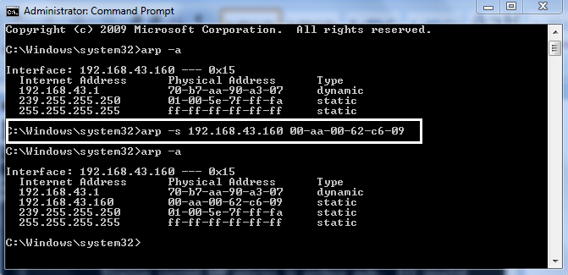

Remove ARP entry

We can also remove the arp entries irrespective of the entry type, such as **static** and **dynamic**.

**Steps for removing an ARP entry**

**Step 1:** To remove an ARP entry type, the command **arp -a**. This command will display all the ARP entries with their IP address, MAC address, and the entry type.

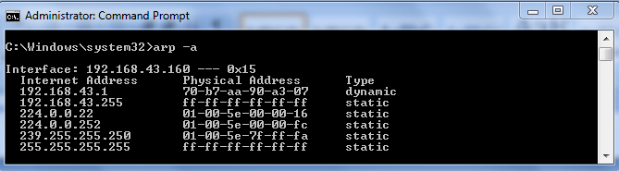

**Step 2:** Now, type the **arp -s** command along with the IP address, which we want to delete and then press enter. It is necessary that the **IP address** must be from the listed entries.

1. Syntax: arp  -d  192.168.43.255

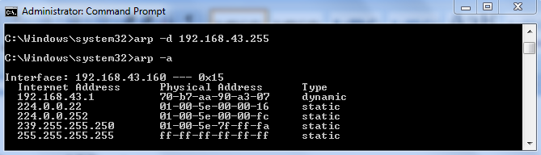

In the above example, we have deleted the entry having IP address 192.168.43.255.

**Step 3:** To check whether the entry is deleted or not again type **arp -a** command and press enter key. After pressing enter key, all the entries will be displayed in the command prompt except the deleted one.

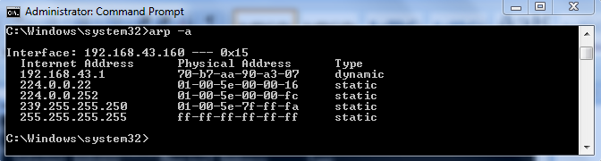

In the above figure, the entry having IP address 192.168.43.255 is not present.